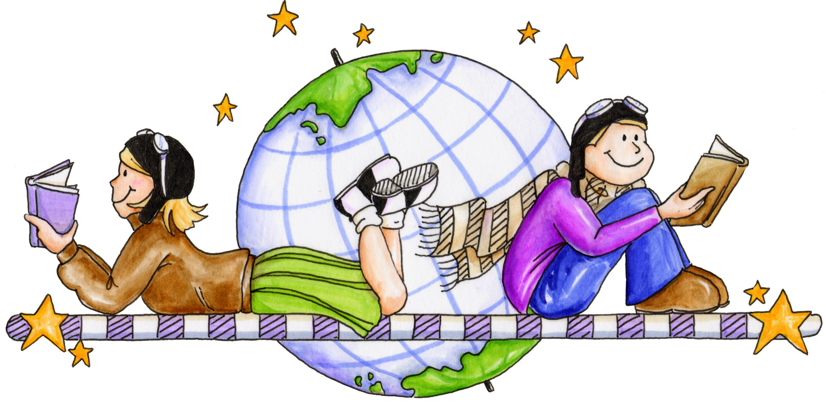  Language and Literacy activities including:  - Reading groups in class. Read chapters for homework. Use Bloom’s Taxonomy questions for reading tasks. Bloom’s questioning extends and develops comprehension skills.  - Listening and talking: P7 weekly news reports about school events and pupil work. Everyone will take a turn to report.  - Design tourist brochures to describe the wonderful landscape and environment we live in. Share this with email pals in NZ.  - Research and report on the Picts, Celts and Maori people, their way of life, culture and how their history was recorded. |  |  |   Mathematics and Numeracy activities including:  - Look at symmetry and angles in everyday life. Use symmetry in Celtic and Maori design.  - Revise and extend our understanding of fractions, decimals and percentages.  - Begin weekly mental maths tests that correspond to homework tasks  - Discuss and use BODMAS. Investigate Powers and Roots  - Revise 12 and 24 hour time. Investigate time taken to perform tasks.  - Continue Problem Solving strategies and discuss the importance of ‘showing all my working’. Extend pace and challenge with interesting tasks.
Health & Wellbeing activities including:  - Continue with new cooperative learning groups. Play games to encourage praise, participation, group success and class success.  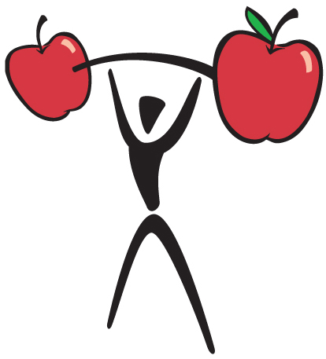  - Start Gratitude Diaries to focus on things we are thankful for in our lives.  - Complete block of Dance in gym, concentrating on strength and creativity. Learn dance from different cultures.  - Encourage use of personal free writing jotters to record thoughts and feelings.  - As we examine our own environment and that of another culture we will reflect on the lives of people in history and how they are different from our own. |  |  | Contexts for Learning:  This term our topic is Scotland and New Zealand. Initially we will be communicating by email and letters, with school children in the central North Island of NZ. We will share information about our families, culture and the best things about our countries.  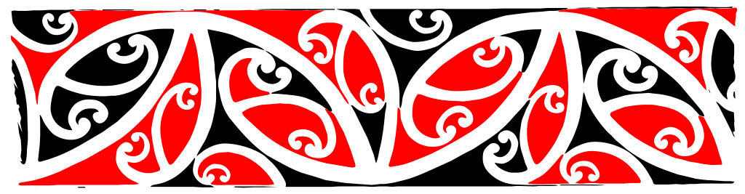  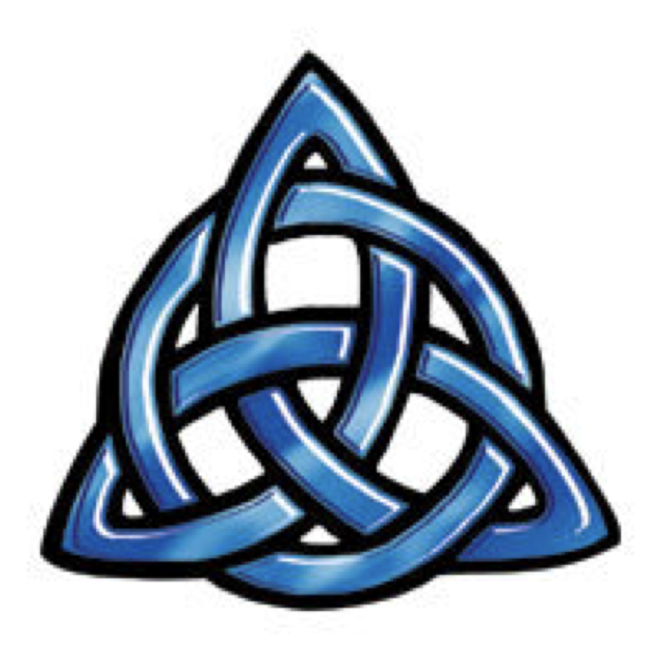  Following on from this we will examine The Picts and Celts and compare their way of life with the early Maori in NZ. We hope to visit the Crannog and share our learning using research, reports, power point presentations and the creation of model Crannogs and Maori Pa (villages).
Parent Open Sessions  Friday 1st November  Friday 6th December | Wednesday 13th November  Charity Day: Wear it Pink  Breadalbane’s Got Talent | Inservice Days  14th and 15th November |  | Road Safety Week 18th – 22nd November | Christmas Concert  Wednesday 18th December | 