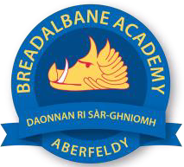
Breadalbane Academy
National Qualifications - Course and Assessment Overview 2021 / 2022
SUBJECT: Biology LEVEL: N5
Term 1  August - October |  | Term 2  October - December |  | Term 3  January - March |  | Term 4  April - May
Course Content | Type of Assessment /  Completion Date | Course Content | Type of Assessment /  Completion Date | Course Content | Type of Assessment /  Completion Date | Final Assessment Composition and Date
Unit 3: Life on Earth  Unit 1: Cell Biology | Life on Earth Class Assessment | Unit 1: Cell Biology | Cell Biology Class Assessment | Unit 2: Multicellular Organisms | Prelim examination  (Life on Earth & Cell Biology)  January 2022 | SQA Examination  May 2022

