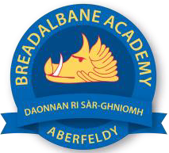
Breadalbane Academy
National Qualifications - Course and Assessment Overview 2021 / 2022
SUBJECT: Chemistry LEVEL: AH
Term 1  August - October |  | Term 2  October - December |  | Term 3  January - March |  | Term 4  April - May
Course Content | Type of Assessment /  Completion Date | Course Content | Type of Assessment /  Completion Date | Course Content | Type of Assessment /  Completion Date | Final Assessment Composition and Date
Unit: Inorganic Chemistry  + Part of Researching Chemistry | Class test:  Inorganic Chemistry | Unit: Physical Chemistry & Researching Chemistry (part) | Class test:  Physical Chemistry | Organic Chemistry and complete Researching Chemistry | Prelim examination  (Inorganic & Physical Chemistry with part Researching Chemistry)  January 2022 | SQA Examination  May 2022

