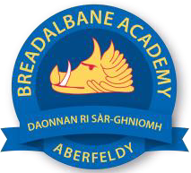
Breadalbane Academy
National Qualifications - Course and Assessment Overview 2021 / 2022
SUBJECT: English LEVEL: National 5
Term 1  August - October |  | Term 2  October - December |  | Term 3  January - March |  | Term 4  April - May
Course Content | Type of Assessment /  Completion Date | Course Content | Type of Assessment /  Completion Date | Course Content | Type of Assessment /  Completion Date | Final Assessment Composition and Date
Close Reading RUAE Baseline Assessment  1st Drafts of Creative and Persuasive Portfolio | Monitoring – September  Monitoring – September / October | Depending on class teacher students will tackle either Scottish Set Text, Critical Essay  or  4.3 - National 4 assessments  or  4.1/ 4.2 Final Draft of Portfolio 30% of Grade | Monitoring - November  Unit Assessments – November and December  Final Draft - December | Full Prelim  Close Reading RUAE Exam  Critical Reading Exam  4.3 / N5a - Final Draft Portfolio 30% of Grade | Monitoring  January  January  End of January | Close Reading RUAE Exam 30% 12th May 2022  Critical Reading Exam 40%

