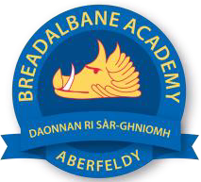
Breadalbane Academy
National Qualifications - Course and Assessment Overview 2021 / 2022
SUBJECT: FRENCH & SPANISH LEVEL: HIGHER
Term 1  August - October |  | Term 2  October - December |  | Term 3  January - March |  | Term 4  April - May
Course Content | Type of Assessment /  Completion Date | Course Content | Type of Assessment /  Completion Date | Course Content | Type of Assessment /  Completion Date | Final Assessment Composition and Date
Society  - Family & Friends  - Lifestyles | Unit Assessments in Reading & Listening  End of September | Society  - Citizenship  Learning  - School  - Learning Types | Exam style paper  By mid-November | Employability  - Summer jobs  - Future plans | Speaking Test  By mid-March | - Reading  - Writing  - Listening  French: 3/5/2022  Spanish: 17/5/2022

