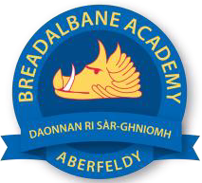
Breadalbane Academy
National Qualifications - Course and Assessment Overview 2021 / 2022
SUBJECT: Geography LEVEL: AH
Term 1  August - October |  | Term 2  October - December |  | Term 3  January - March |  | Term 4  April - May
Course Content | Type of Assessment /  Completion Date | Course Content | Type of Assessment /  Completion Date | Course Content | Type of Assessment /  Completion Date | Final Assessment Composition and Date
Selecting Geographical issue and Ongoing work on Geographical study. | Ongoing assessment with feedback on a week to week basis | Geographical Study  First draft  Geographical issues  First draft | Late November  December | AH Geog  Re assessment opportunities  Catch up assessments | Late January  February | See SQA website  https://www.sqa.org.uk/sqa/files_ccc/nq-2022-exam-timetable.pdf  AH Geog: 9-11.30 27th April

