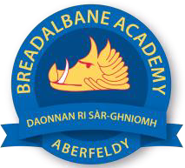
Breadalbane Academy
National Qualifications - Course and Assessment Overview 2021 / 2022
SUBJECT: Geography LEVEL: National 5
Term 1  August - October |  | Term 2  October - December |  | Term 3  January - March |  | Term 4  April - May
Course Content | Type of Assessment /  Completion Date | Course Content | Type of Assessment /  Completion Date | Course Content | Type of Assessment /  Completion Date | Final Assessment Composition and Date
Rivers/Limestone assessment N5 Geog  Population assessment  N5 Geog | Early October  Early October | Skills questions  Urban  N5 Geog | December | Prelim  N5 Geog  Re assessment opportunities  Catch up assessments | Early January | See SQA website  https://www.sqa.org.uk/sqa/files_ccc/nq-2022-exam-timetable.pdf  N5 Geog:12.30-14.25 27th April

