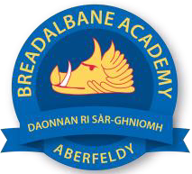
Breadalbane Academy
National Qualifications - Course and Assessment Overview 2021 / 2022
SUBJECT: Engineering Science LEVEL: N5
Term 1  August – October |  | Term 2  October – December |  | Term 3  January – March |  | Term 4  April – May
Course Content | Type of Assessment /  Completion Date | Course Content | Type of Assessment /  Completion Date | Course Content | Type of Assessment /  Completion Date | Final Assessment Composition and Date
Engineering Contexts and Challenges – Energy  Electronics and Control – Digital Electronics  Electronics and Control – Programmable Control | September 2021  September 2021  October 2021 | AAR assessment  Mechanisms and Structures – Structures  Mechanisms and Structures – Structures (Materials)  Mechanisms and Structures – Mechanisms  Electronics and Control –  Analogue Electronics (part 1) | October 2021  November 2021  November 2021  December 2021 | Prelim  Electronics and Control –  Analogue Electronics (part 2)  Mechanisms and Structures – Pneumatics  Engineering Contexts and Challenges – Engineering Systems | Tues 11th January  February 2022  March 2022  March 2022 | Written Exam  18th May 2022

