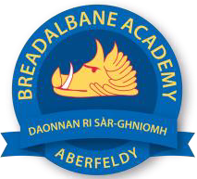
Breadalbane Academy
National Qualifications - Course and Assessment Overview 2021 / 2022
SUBJECT: Physical Education LEVEL: National 5
Term 1  August - October |  | Term 2  October - December |  | Term 3  January - March |  | Term 4  April - May
Course Content | Type of Assessment /  Completion Date | Course Content | Type of Assessment /  Completion Date | Course Content | Type of Assessment /  Completion Date | Final Assessment Composition and Date
Factors Impacting Performance (Mental, Emotional, Social and Physical)  Data Collection: Physical Fitness and Emotional  Approaches to Develop: Physical Fitness and Emotional |  | Data Collection: Physical Skills and Mental Factors  Approaches to develop: Physical Skills and Mental  Mini Performance Development Programme | Section 1 of Portfolio  October | Data Collection  Performance Development Programme  Evaluating Performance Development Programme | Sections 2 and 3 of Portfolio  Written Portfolio (50%)  Completed by Easter Holidays | Course Assessment: Performance 50%

