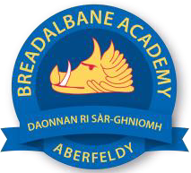
Breadalbane academy
National Qualifications - Course and Assessment Overview 2021 / 2022
SUBJECT: History LEVEL: AH
Term 1  August - October |  | Term 2  October - December |  | Term 3  January - March |  | Term 4  April - May
Course Content | Type of Assessment /  Completion Date | Course Content | Type of Assessment /  Completion Date | Course Content | Type of Assessment /  Completion Date | Final Assessment Composition and Date
Advanced Higher History  Germany: from democracy to dictatorship – Weimar Republic | Past Paper Essay Questions | Advanced Higher History  Germany: from democracy to dictatorship – Weimar Republic | Past Paper Essay Questions and Source Questions + preparation for dissertation | Advanced Higher History  Germany: from democracy to dictatorship - Nazi Germany | Prelim + Dissertations | May

