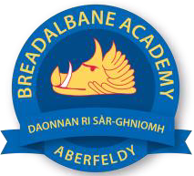
Breadalbane academy
National Qualifications - Course and Assessment Overview 2021 / 2022
SUBJECT: History LEVEL: Higher
Term 1  August - October |  | Term 2  October - December |  | Term 3  January - March |  | Term 4  April - May
Course Content | Type of Assessment /  Completion Date | Course Content | Type of Assessment /  Completion Date | Course Content | Type of Assessment /  Completion Date | Final Assessment Composition and Date
Higher History  Britain 1851-1951 | Past Paper Essay Questions | USA, 1918-1968 | Past Paper Essay Questions | Impact of the Great War on Scotland, 1 +914-1928 | Prelim +  Source Questions | May

