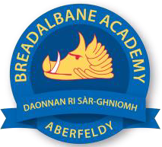
Breadalbane Academy
National Qualifications - Course and Assessment Overview 2021 / 2022
SUBJECT: Religious, Moral and Philosophical Studies LEVEL: National 5
Term 1  August - October |  | Term 2  October - December |  | Term 3  January - March |  | Term 4  April - May
Course Content | Type of Assessment /  Completion Date | Course Content | Type of Assessment /  Completion Date | Course Content | Type of Assessment /  Completion Date | Final Assessment Composition and Date
National 5 RMPS –  World Religion – Buddhism  Morality and Belief - Morality and Relationships | Written pieces throughout the term. Marked and handed back for revision.  Exam Practice questions (not timed.)  As above | National 5–  Religious and Philosophical Questions – The Problem of Evil and Suffering | Written pieces throughout the term. Marked and handed back for revision.  Exam Practice questions (not timed.)  Practice, timed, exam in class for Buddhism and Philosophical Question at end of term. | National 5–  Morality and Belief – Morality and relationships review  Problem of Evil and Suffering review | Prelim for all topics.  Written pieces throughout the term. Marked and handed back for revision.  Exam Practice questions (not timed.) | Timed second prelim in class (one period per topic.)  SQA Paper  16/5/21

