**Messy Play**

Last week we made ooblex, which is just cornflour and water. Everyone loved experimenting in with mixing different colours and amounts. There were lots of good conversations going on, guessing what would happen each time something new was added.

**Outdoor Play**

On Thursday the whole nursery went to the tennis courts to take part in some sports activities. Little did we know we would be met with hundred’s of worms. The nursery children spent a long time moving the worms safely in to the bushes. There was lots of talk about the size of different worms and what they eat. We did do some P.E eventually!

Nursery news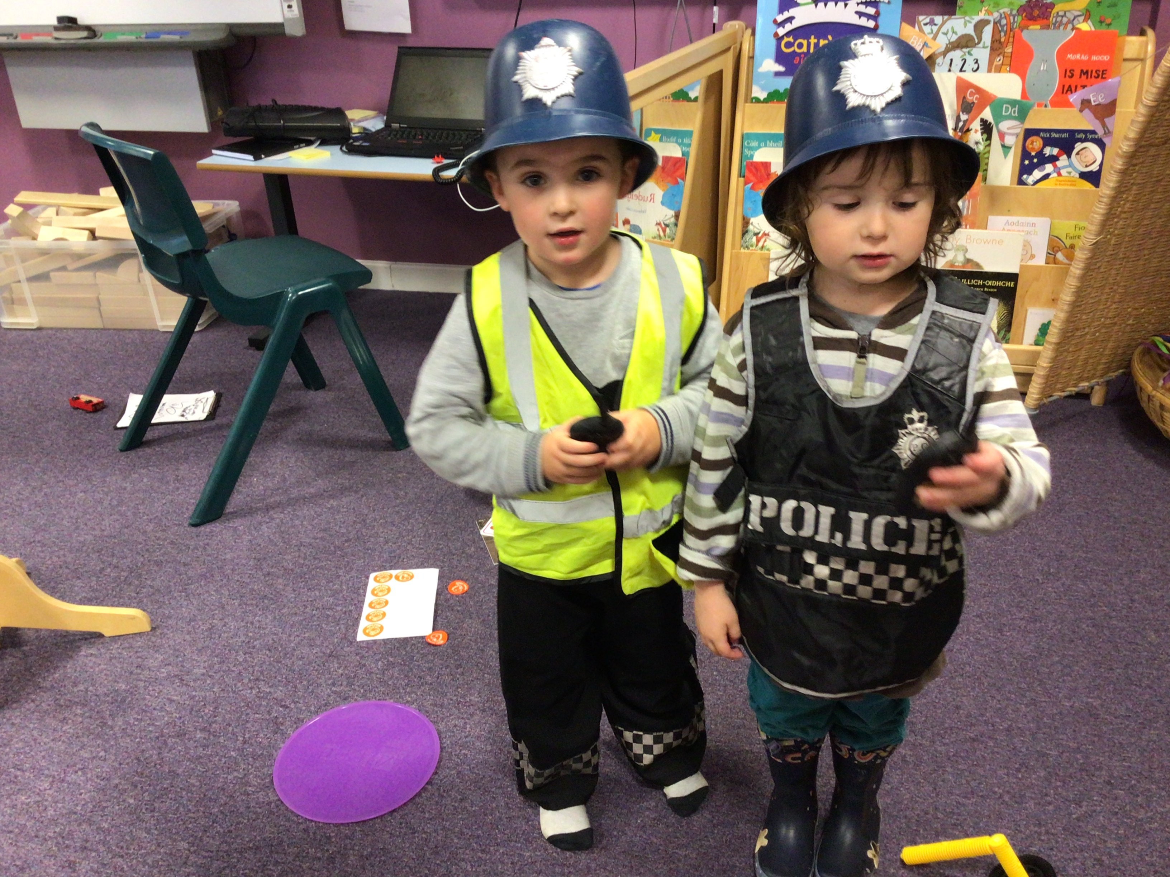

**Play in Pedagogy**

Miss Rocsik has had us on a letter treasure hunt this week. We used different tools to find familiar letters. It then became a playground for all the animals to live in. We added lots of natural resources to the sand for the animals to eat. Our Play in Pedagogy activities starts as adult directed play and it is great to see how the children adapt and change it over the week.

**Other Information**

